**In Attendance:**

**PAC Members (via Zoom):** Laurel Horn (President), Sandra Young (Vice-President), Sarah Cranfield (Treasurer), Pamala-Rose-Combs (DPAC Rep), Tara Rozenek (Secretary), Tyree Buchanan, Michelle Kehler, Rumin Jiang, Jana Hikichi, Kim Leifso, Jessie Williams, Claudia and Brad Broten, Elizabeth Buhler

**Staff:** Mr. Dean Pacheco, Principal

**Guests:** none at this meeting

**Call to order:** The meeting was called to order at 7:10pm by President, Laurel Horn

**Welcome & Introductions:** Laurel welcomed all the parents to the PAC meeting

**Approval of Minutes:** The minutes of the November 2020 meeting were accepted as presented

**Principal’s Report: (Mr. Pacheco)**

* + It has been quiet and slow during what is typically a busy time of year, with none of the usual holiday events taking place. The school is ramping up for report cards which will be issued next Wednesday, December 16th. Next week is also Christmas week, organized by grad council. Tuesday is the Teacher Appreciation event. On Friday, there won’t be the usual Christmas assembly; Mr. Powell is putting together a virtual assembly for the school to enjoy. The pancake breakfast on Friday will take place without the community this year; only staff & students. The breakfast is a fundraiser for the breakfast club.
  + A couple of weeks ago, the school had a week with several exposure letters; a couple of the notices were quite dated, with the students already back in school by the time they were distributed. No names can be provided for those affected, but seems a couple letters were issued for 1 student. Made for a stressful week; many kids missed school for a few days following. Most have returned; a few still staying home until the break.
  + A concern was brought forward about having a space for students to eat lunch. Staff have rooms available for first 10-15 minutes of lunch; some students utilize, but most don’t and choose to go outside and get fresh air. There are a few physically distanced tables in cafeteria with 1 chair at each table; many utilize those tables. Staff are there, once students are done, they wipe down table & chair for others to use. Common areas need to be closed for seating; would need to have someone go around and clean up after every single student in order to follow health & safety protocols.
  + Staff are looking at for Quarter 3 and Quarter4 to have a single lunch as opposed to the staggered lunch, to increase school culture activities. Have done the single lunch a couple of times this year so far and went well having everyone out at the same time.
  + Staff have been encouraged to open windows in classrooms more often for fresh air. Some staff are doing it; some are leaving doors open to hallway.
  + With the increased exposure letters, this has increased anxiety around the school. Dean went on PA system to address the student body to calm the anxiety. Discussed how important it is to take care of everyone; not a time to blame, a time to support. Reiterated that when outside to practice physical distancing or wearing masks are recommended. More students do seem to wear masks outside and in the class. No negative comments about wearing masks; it is accepted and treated equally, which has been great.

**President’s Report: (L. Horn)**

* + Christmas Teacher Appreciation event this year has been adapted and will be held next Tuesday, December 15th. On Monday evening, Laurel, Jessie & Claudia will set up. Purchased about 100 small gifts and will display buffet style. Approved budget of $500, voted on by PAC. Gifts include specialty coffees, little Christmas candies; about 5 different choices for staff to select. Staff can come through, physically distance, and feel acknowledged. Parents are invited to write letters / notes of recognition for staff and these will be posted around the table for staff.

**Treasurer report (Sarah)**

* + Gaming Account Balance as at Oct. 31, 2020, $19,522.92
  + General Account Balance as at Oct. 31, 2020, $3,095.20 plus $205 in school fees still with Barb (will wait until after break if any additional donations come in)
  + Co-op cards - $437.29

Draft 2020/2021 budget distributed. The draft needs to be distributed a minimum of 2 weeks to school community, so will be voted on at next PAC meeting in January.

.

**DPAC report (Pamala)**

* Gord was at this month’s meeting and discussed the exposure letters. Pointed out that in a district of 22,000 students, the handful of letters sent out has been minimal; exposure rate is not very high. Reminder that an exposure does not mean an outbreak.
* Bylaws, constituions and policies for DPAC were reviewed. The PAC will review and vote on these in January

**New business**

**Staff appreciation Dec. 15:**

Socially-distanced Christmas coffee break will be held on Dec.15- Laurel, Claudia, & Jessie to set up the night before. Put out a call out on Facebook for any general thank you/holiday wishes notes from parents to staff. Could be emailed to Laurel or dropped off at the office. They will display any notes received to decorate around the gift table.

**Options for creating outdoor spaces in the courtyard (Laurel & Marcel)**

Laurel distributed presentation of some outdoor spaces ideas, some courtyard options. Had previously discussed ways to create more usable, covered spaces in and around the school with COVID, utilizing outdoor space. Shared these options. Option #1 big L in the courtyard, attached roofs bolted in. Option #2: more of the regular covered shelter tents used for special events; flexibility of tents that can move for other events.

Expensive to do square footage. 2300 sq feet of covered space Local companies can be used to install and would be approximately $25,000. Removable tents are $5,000 cheaper, but with flexibility to use tents for other events. Would like to see teacher input on options; what are they likely to use. Dean will call a meeting with staff in early January to get feedback on this topic. There is some urgency attached, as the money is available at district level, may not be available for much longer. Funding is there, but won’t be there for very long; first come, first serve. Schools that have a plan and actual cost will get the money. Laurel will connect with Gord to define what is ‘soon’ and also determine a ballpark for the amount that is being allotted to schools.

**Discuss and approve PAC budget for 2020-21 school year**:

Proposed budget was reviewed for any possible changes. The budget was tabled for approval at the January meeting.

Concern with Foundation Account, as there is no money in Foundation, even though it has been budgeted. A concern there won’t be those scholarships funds, and scholarship funds have to be paid out of General. Are we going to fund it ourselves and pull out of Gaming; need to make that decision. Do we stop using the Foundation altogether? Preference is to pay it direct, and move scholarship funds into Gaming account. This provides confirmation that the money was used & paid out this way, also. It was agreed to move scholarships to the Gaming Account.

Dry grad donation: Grad newspaper feature - pay $400 to school, not grad committee; split out the funds for dry grad and paper feature.

Should we consider donating one of our $50 co-op gift cards to the Christmas hampers or any other Christmas donation that is needed? Dean confirmed that yes, if any money can be given to hampers that would be great. There is $1000 donation from firefighters towards hampers; will be divided amongst families. Supporting 12 hampers this year.

**Motion – To move the full amount in the Otter Coop Gift Cards Account ($437.29) to be used for Christmas hampers**

* Motion made by Pamala
* Seconded by Tyree. ***Motion carried***

Year end bus driver and staff appreciate year end lunch - $150 – to be moved from the Otter Coop Gift Cards account to the General account.

Will need to meet in January to approve and vote in the budget

**2020-2021 PAC Meetings:**

* Nov.12 AGM
* Dec.10
* Jan. 14
* Feb.11
* *(Mar.11 if needed)*
* Apr.8
* May 13
* Jun.10

**Meeting Adjournment:** The meeting was adjourned at 8:20pm.

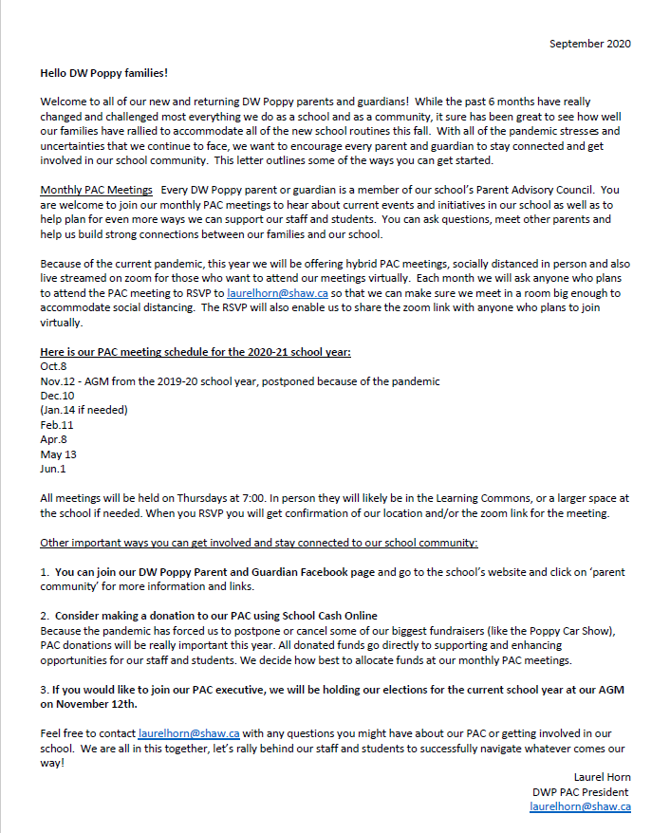

**DPAC - Gaming Fund Reference Guide**