**In Attendance:**

**PAC Members (via Zoom):** Laurel Horn (President), Sandra Young (Vice-President), Sarah Cranfield(Treasurer), Pamala-Rose-Combs (DPAC Rep), Tara Rozenek (Secretary), Tyree Buchanan, Jana Hikichi, Claudia and Brad Broten, Michelle Kehler, Kerri Sketchley, Marnie Wilson, Tina Upton

**Staff:** Mr. Dean Pacheco, Principal

**Guests:** Ms. Casey Murray

**Call to order:** The meeting was called to order at 7:05pm by President, Laurel Horn

**Welcome & Introductions:** Laurel welcomed all the parents to the PAC meeting

**Approval of Minutes:** The minutes of the December 2020 meeting were accepted as presented

**Principal’s Report: (Mr. Pacheco)**

1. Before the break, Christmas week was a great experience for students & staff. There was a door decorating contest, different theme days, a smaller pancake breakfast, staff activity. They were nice distractions. Would like to give a big thank you to grad counsel who were instrumental in organizing that week. Also would like to thank staff, students and especially Mr. Powell for putting together the video in lieu of the assembly.
2. It was a tough start back after the break. There was the loss of a grad and another grad who was seriously injured in an accident. It was quite difficult for the school community to come back to that.
3. While there is some light at the end of the tunnel with a vaccine, we do foresee these health and safety protocols to be in place for some time still. Need to ensure they continue to be followed; staff and students have been doing a great job at this.
4. The end of Quarter 2 is fast approaching. The grade 8shave been in semester courses with the same group since September. This will come to a close, and they will move into their next semester and group of classmates. Only 2 weeks left to end of quarter. I would encourage parents to connect with teachers to check on the status of students; reach out to case managers if there is an IEP, or counsellor or VP if needed. Homework club is available for extra assistance before & after school, from 8am – 8:30am and 2pm – 2:30pm, with staff there to support.
5. There has been an Increase in vandalism in and around the school. Spray painting occurred on the school grounds and in bathrooms.

**President’s Report: (L. Horn)**

* The outdoor learning spaces project is still being worked on. Any funding requests need to be submitted by principals. There are a number of schools asking for funding for an outdoor space; applications will be reviewed in January, so we need to move quickly on gathering the information to have our request submitted.
* Dean has asked around to the staff and the 1st option was most interesting to staff, the L shaped roofing with skylights, attached to wall. Staff have also requested picnic tables (est. cost $25,000, we will get an exact quote so Dean can formally submit our funding request). Anything over $5000 requires multiple quotes.

**Treasurer report (current balances) (Sarah)**

* + Gaming Account Balance as at Dec. 31, 2020, $19,522.92
  + General Account Balance as at Dec. 31, 2020, $3,095.20 plus $205 in school fees still with Barb (will be collected in January)

**DPAC report (Pamala)**

Every single school in the district is now part of BCCPAC. Scholarships are available for all grade 12s if their school if a member.

The by-election for candidates will be held on February 27th, 2021. Hoping to organize a special zoom meeting with all candidates if possible. If not, a questionnaire will be sent out with responses available for review.

DPAC would like to support the school district with the production of a rainbow crosswalk to be placed between Langley RCMP & School District as a symbol of inclusiveness and in support for LGBTQ. The thought is if it is placed in front of the Langley RCMP building, it will decrease the likelihood of being vandalized. DPAC would like to donate $1000 to this endeavour and is asking for PACs to support this contribution of funds towards the rainbow crosswalk. This is a good community initiative. Question for the Poppy PAC: Is it a good idea for DPAC to spend $1,000 on this endeavour? Unanimous vote of yes; Pamala will vote yes on behalf of Poppy.

**New business**

1. **Request from Lynn Fripps to add Reading Buddies link to our FB page – volunteer opportunity for students; applications due January 23rd.**

Request submitted by Lynn Fripps Elementary PAC to post the Reading Buddies information on our school website, Facebook page, PAC page and any emails that may be sent out to students and/or parents to raise awareness of the program.  We would really like this program to be a success and feel since school this year is a lot different than the past, students in our community would love an opportunity to get to obtain volunteer hours required for graduation. Agreed to link this to the Poppy FB page

1. **PE and Athletic Departments funding requests**

Ms. Casey Murray brought forward a couple of funding requests from the PE and Athletics departments. PE department asking for $1665 or $4500 for new CPR mannequins. CPR is part of the PE grade 10 curriculum. Over years, current mannequins used are made of plastic & foam and have been well-used in many years that have had them. If we are going to continue to offer the program to students, need to replace a large number of the mannequins. Company has offered next version up, where the mannequins are more durable, higher quality; comparable in price, and works better with AED machines. Question was raised if these can be purchased in chunks, buy 2 or 3 sets at a time. 15 of the 24 mannequins are still in decent condition, so could be ok with purchasing a few at this time. Ms. Murray can send a link to the company we use that has more detail on mannequins.

Athletics department asking for $3000-$4000 for new basketball jerseys for Gr.8 girls and Gr.9/10 boys. There is a large cost in replacing uniforms; has been a number of years since these were replaced. Basketball uniforms require a top & bottom and also 2 sets, one for home and one for away. BC School Sports is strict on the amount of sponsorship that schools can get and can be displayed on the jerseys, so that is not an option. District has policies – can’t have advertising on jerseys. Could Athletics provide a spreadsheet of the current status of all uniforms; how old they are, etc. so a priority list can be established as to what needs to be replaced. This would provide PAC with a heads up on what might be coming up, and can help to allocate some budget towards uniforms as a regular ongoing expense. Ms. Murray will put this together and send.

1. **Budget towards outside learning space?**

Outdoor space benefits more students for a longer period of time. There was discussion about possible PAC fundraising towards an outdoor space. There might be more appeal since it benefits more students, so there might be more interest in contributing.

Need to develop a sub-committee to ensure this project keeps momentum. Information needs to be pulled together rather quickly with the application deadline fast approaching. Some questions: is sponsorship a possibility? Can we apply for grants? Dean will look into this. Please connect with Laurel if you are interested in sitting on this sub-committee within the next couple of days. Send an email to Laurel if interested. Jana will look into the table options; biggest thing is durability. Need to keep project rolling, and fine-tuning what was recommended at December meeting.

1. **Discuss and approve PAC budget for the 2020-21 school year**

Discussion on what needs to need to be prioritized for this year. Outdoor space is priority. Need to know if we will be getting the money from the district. To set budget, decided the general consensus would be to prioritize the outdoor space at this time, and then revisit other funding requests.

Agreed that the funding requests brought forward from PE and Athletics are important. PE 10 is still mandatory for those students, and jerseys represent Poppy. An idea was to put a line item in the budget for uniforms, extra-curricular expenses each year. Should we look into fundraising for the mannequins? Can the school fund part of it? Can this be put off for a year and re-visit?

**Vote: To accept the budget as presented. Unanimously accepted**

Scholarships; need to decide how we will pay with the possible three (3) options below.

Foundation account has $451 in it.  We can use it for the 2021 scholarships, but they do charge 5% to do this so our $1,000 scholarships will cost us $1,050.  We should discuss if we'd like to do this, or pay the recipients directly.  Based on this, we can adjust the budget figure accordingly. Below are three (3) options:  
  
1. Send the foundation $74 to cover one scholarship, we pay the other directly ($500-$451+$25 admin fee).  Total cost $574.  
2. Send the foundation $599 to cover both scholarships this year.  Total cost $599.  
3. Pay the $1,000 directly to scholarship recipients out of current funds and leave the $451 with the Foundation for now.  Total cost $1,000 but we have a $451 credit with Foundation still.

**Option 3 was decided – pay scholarships directly, and leave funds in Foundation account**

Next meeting: February 11th, 2021

**2020-2021 PAC Meetings:**

* Nov.12 AGM
* Dec.10
* Jan. 14
* Feb.11
* *(Mar.11 if needed)*
* Apr.8
* May 13
* Jun.10

**Meeting Adjournment:** The meeting was adjourned at 8:58pm.

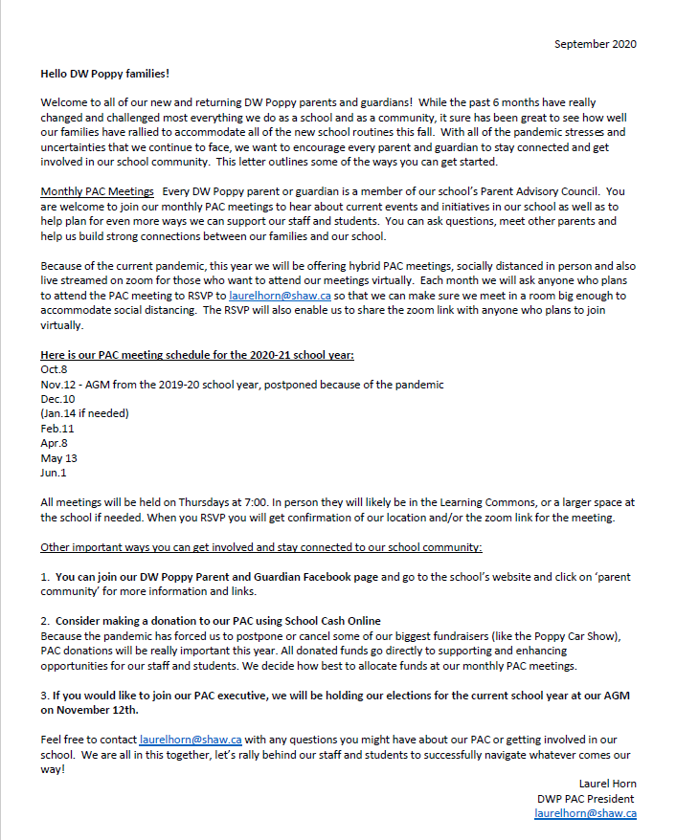

**DPAC - Gaming Fund Reference Guide**